Please Consider Supporting Your Local Hawkwatch

Allegheny Front Hawk Watch (AFHW) is part of the Allegheny Plateau Audubon Society (APAS). Our information is below:
Website: http://www.alleghenyplateauaudubon.org/
Facebook: Allegheny Front Hawk Watch
Latest Count Data: www.hawkcount.org
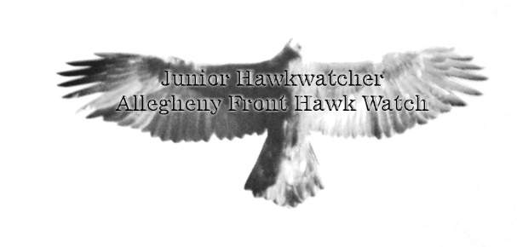
Twitter: audubon@apasnews
Contact the president of the APAS at: brianwargo@gmail.com

The Hawk Migration Association of North America (HMANA) is a national organization that promotes hawkwatching and provides resources for the hawkwatching community. This includes free raptor identification materials, the free hawkcount.org website, and published Hawk Migration Studies (the journal of HMANA-subscription required). For more information and resources, use the following web address:
http://www.hmana.org/
This booklet was written by Brian M. Wargo, who is solely responsible for its content. All photos, diagrams, and other inscriptions are also by the author—no copyright laws have been violated.
242
Junior Hawkwatcher Program
for the
Allegheny Front Hawk Watch
This young hawkwatcher is learning to use binoculars!

Sponsored by:
The Allegheny Plateau Audubon Society
and
The Hawk Migration Association of North America

Directions
In order to become a Junior Hawkwatcher at Allegheny Front Hawk Watch, complete the number of activities that matches your age. If you are 8-years old, then complete eight activities. If you are twelve years old, then complete 12 of the activities. If some of the words or work is difficult, you may have your parents help. Once completed, please take this booklet to the official counter of the day. The booklet will be checked for accuracy and if found to be correct, the junior hawkwatcher will be awarded a certificate.
Please fill in your information below:

What is your name? _______________________________________

What is your age? ________________________________________

Where are you from?______________________________________

What is your favorite bird?_________________________________

Is this your first time at a Hawkwatch?________________________

Have you ever seen an eagle?________________________________

2
The Young Hawkwatcher’s Pledge
(Age 11 and Younger)

I, ______________________________, pledge to protect hawks and birds. I can make this possible by not littering or using poisons, such as lead and rat killer. I am becoming a hawkwatch member and one way I can make this possible is to share my memories with my friends and family.
Senior Hawkwatcher Signature Required Below
I, ______________________________, certify that ______________________________ has completed
this hawkwatching program.
Date: ______________________
23
The Hawkwatcher’s Pledge
I, ________________________________, have completed the appropriate number of activities for my age, and am beginning my journey to becoming an advocate for migrating raptors. Like people, migrating raptors need clean water, clean air, and food that is free from toxins. I promise to share what I have learned here with my family, my friends, and my teachers. When hunting and fishing, I will try to use non-lead alternatives. If I ever have a mouse problem, I will consider using mechanical mousetraps instead of poisons. I will also do my part to keep the environment clean, healthy, and safe for all wildlife, so that they can help the raptors survive. Most of all, I will let other people know that getting outside and watching raptors is good for the body and the mind.
Senior Hawkwatcher Signature Required Below
I, ___________________________________, certify that _________________________________ has met the requirement to become a Junior Hawkwatcher at the Allegheny Front Hawk Watch, on this date of ____________________________, 20______.
22
Background Information
The Allegheny Front Hawk Watch was established in 1989 by several naturalists who were concerned about wildlife and birds of prey in particular. Birds of prey are often called raptors, which include eagles, falcons, vultures, osprey, harriers, accipitors, and buteos. These bird are often called “hawks”, but the term hawk really refers to specific types of raptors. The common Red-tailed Hawk is a hawk (in the genus Buteo), but the Peregrine Falcon (in the genus Falco) is not. Regardless of the name, a hawkwatch is a designated effort to collect information about migratory raptors.
Most hawkwatches, like the Allegheny Front Hawk Watch, have a designated spot where hawkwatching takes place. Dr. Tom Dick, a veterinarian, purchased the land that you are standing on in 1990, for the sole purpose of creating a hawkwatch. A dedicated group of hawkwatchers helps run the Allegheny Front Hawk Watch. Hawkwatchers are the people, usually volunteers, that spot, identify, and attempt to age and sex (tell if the raptors are male or female) each raptor that passes the hawk site during the migratory seasons.
Allegheny Front Hawk Watch attracts many hawkwatchers and several function as hawk counters, the people who tally the number of migrating raptors by species. Every day from mid-August through the early part of December, one of our official counters is responsible for tallying every migratory raptor that passes this site. Their job is ensure that the numbers counted are accurate and to record the environmental data (weather) every hour. At the end of each day, the official counter enters this data into the hawkcount.org website, where it is shared with scientists and the general public. Anyone with access to the internet can see the data from the Allegheny Front Hawk Watch and the hundreds of other sites from across the continent.
3
What Makes the Allegheny Front Hawk Watch Special?
Most hawk sites count either during the fall or the spring migration. The Allegheny Front Hawk Watch does both. Since the year 2000, the Allegheny Front Hawk Watch counts from mid-February through early May. This makes Allegheny Front Hawk Watch a very important hawk site.
The Allegheny Front Hawk Watch is also famous for its Golden Eagle numbers, holding the record for the fall count in the Eastern Flyway with 320 Golden Eagles. They also hold the one-day record, counting 74 Golden Eagles in one day. You might say that the Allegheny Front is the Golden Eagle capital of the East Coast!
Many hawk sites are difficult to access, requiring a hike up a mountain or ridge. The Allegheny Front Hawk Watch is one of the easiest sites for those with disabilities due to the fact that the parking lot is just a few steps from the viewing area. It is also the most western hawk site in Pennsylvania. Since there is not a single hawkwatching site in the eastern mid-west (Ohio and Indiana) through the western part of the mid-Atlantic (southwestern Pennsylvania), the Allegheny Front Hawk Watch is the last hawkwatch for 500 mile to the west*.
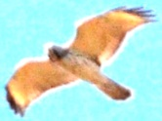
The elevation of the hawk site is 2850 feet above sea level, making the Allegheny Front Hawk Watch the highest Hawkwatch in Pennsylvania.

*Presque Isle Hawk Watch is in Pennsylvania, but is part of the Great Lakes Flyway. Hanging Rock Tower in West Virginia is slightly further west but is 300 miles south of the Allegheny Front Hawk Watch.
4
Activity 17 - Wind Turbines
Climate change is having a monumental effect on migratory birds. Northern raptors are not flying as far south, and some are just not migrating at all. Clearly, we must move away from a purely carbon based energy portfolio to one that relies more on renewable energy. Wind power is promising, but placing wind turbines in the path of migrating raptors can spell bad news!
- What do you think happens to Golden Eagles and Bald Eagles when they encounter a wind turbine? Hint: The tips of the blades move much faster than cars on a highway.

- Who should decide if wind turbines are allowed to operate or be banned from known migratory routes?

- How many eagles should be allowed to be killed by wind turbines for “the greater good?”

Note: The Hawk Migration Association of North America is not opposed to wind energy, but feels that siting is crucial. To learn more about this very important issue, please visit www.hmana.org.
21
Activity 16 – Secret Code News!
Use the following key to decipher important facts at the Allegheny Front Hawk Watch. To keep others from spying on your work, it has been specially coded for you! To decode, simply shift back one letter in the alphabet for each letter. Example: “Tpnf” becomes “Some.”
ABCDEFGHIJKLMNOPQRSTUVWXYZ
Tpnf njhsbujoh sbqupst fbu jotfdut uibu bsf

bmtp njhsbujoh, tvdi bt esbhpogmjft.

Uijt Xbmljoh Tujdl boe Qsbzjoh Nboujt xfsf cpui

qipuphsbqife bu uif Bmmfhifoz Gspou Ibxl Xbudi.
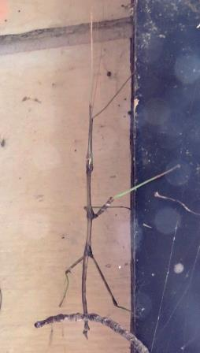
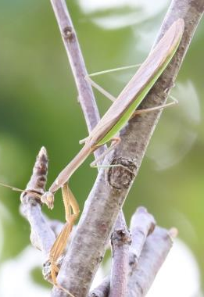

Ju jt jnqpsubou up lffq uif fowjsponfou ifbmuiz tp

uibu njhsbujoh sbqupst ibwf dmfbo gppe boe

xbufs up tvswjwf uifjs kpvsofz.
20
Activity 1 – Connect the Dots

What do you see when the dots are connected?
5
Activity 2 – Which of the following birds are Raptors?
A raptor is a bird that uses its keen eyesight, powerful talons, and curved beak for hunting and feeding on small animals and other birds.

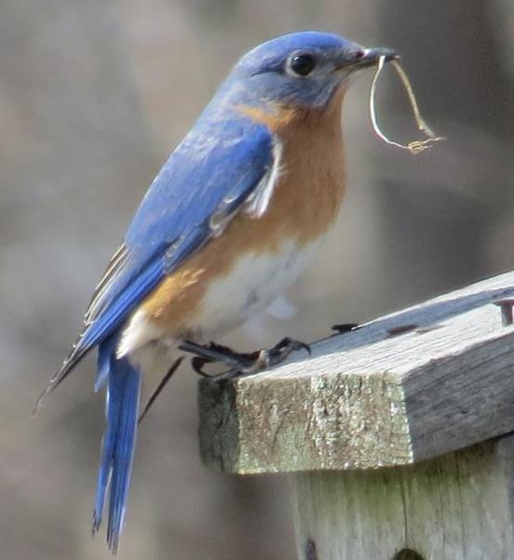
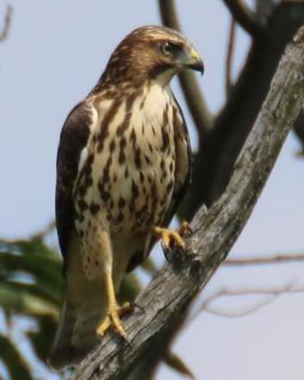Broad-winged Hawk Eastern Blue Bird
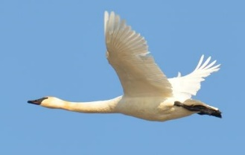
Tundra Swan
6
Activity 15 – Butterflies and Humming Birds
Hawkwatching is all about raptors and the migration. However, raptors are not the only creatures that migrate. The famous Monarch Butterfly also migrates, as does the Ruby-throated Hummingbird. Most hawkwatchers develop a deep appreciation for all migrating creatures.
- Have you seen any butterflies today?

- Were they all headed in one direction?

- Was that direction in the same direction as the raptors?

- Do you think they were migrating?

- Did you see any hummingbirds today?

- Were they all headed in one direction?

- Was that direction in the same direction as the raptors?

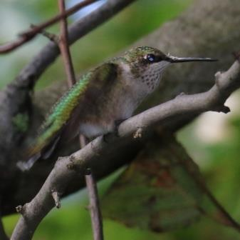
- Do you think they were migrating?

19
Activity 14 - Rodenticides
Red-shouldered Hawks love to eat mice and similarly small sized mammals. This makes most people happy, because people do not want to live near mice. In fact, many people kill mice using rat poison (rodenticide). They put it near their houses, usually in the basement, and it soon kills the mice. The funny thing is that people rarely find the dead mice.
Reports of drowning Red-shoulder Hawks has scientists investigating their deaths. Can you help them solve this mystery?

- Why do you think Red-shouldered Hawks are drowning themselves? Hint: Rodenticides make animals crave water.

- Why do you think people do not find the dead mice? Hint: People try very hard to keep their basements dry so they do not get mold.

- Can you think of a way to help kill mice without using rodenticides?

18
Activity 3 – Interview a Hawkwatcher
Ask one of the hawkwatchers three questions that you are interested in knowing about hawkwatching. Space is provided below for writing either the questions and/or the answers.
Question 1) ______________________________________________
________________________________________________________
________________________________________________________
Response 1) ______________________________________________
________________________________________________________
________________________________________________________
Question 2) ______________________________________________
________________________________________________________
________________________________________________________
Response 2) ______________________________________________
________________________________________________________
________________________________________________________
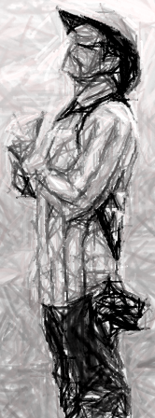
Question 3) ________________________________________
__________________________________________________
__________________________________________________
Response 3) ________________________________________
__________________________________________________
__________________________________________________
7
Activity 4 – Families of Birds of Prey
Family | Genus | Common Species
Accipitriade | Accipiter | Sharp-shinned Hawk, Cooper’s Hawk, Northern Goshawk
 | Buteo | Red-tailed Hawk, Red-shouldered Hawk, Rough-legged Hawk
 | Haliaeetus | Bald Eagle, Golden Eagle
 | Circus | Northern Harrier
Falconidae | Falco | American Kestrels, Merlin, Peregrine Falcon
Pandionidae | Pandion | Osprey
Cathartidae | Cathartes | Turkey Vulture
 | Coragyps | Black Vulture
The raptors usually seen at Allegheny Front Hawk Watch are listed below. Please answer the following questions using this table.
Questions:
- How many species of Falcons are seen at Allegheny Front Hawk Watch?

- How many Genus are in the Family Accipitriade?

- Are Black and Turkey Vultures in the same Family?

- Are Black and Turkey Vultures in the same Genus?

- In which Genus are Bald and Golden Eagles?

- How many types of Osprey are there?

- How many types of Harriers are there?
8
Activity 13 – Lead in Raptors
Bald Eagles are excellent at fishing, being able to catch prey directly from rivers and lakes. Golden Eagles have been known to kill small deer, but prefer to find a carcass to avoid getting hurt during a hunt. Lead is a neurotoxin that damages the nervous system. Scientific studies are showing elevated levels of lead in both Bald Eagles and Golden Eagles. Can you help solve a mystery?

- How do you think lead gets into Bald Eagles? Hint: Fisherman use lead for sinkers?

- Can you think of a way to keep Bald Eagles from ingesting lead?
82
Pb
207.2

- How do you think lead gets into Golden Eagles? Hint: Hunters use lead for bullets.

- Can you think of a way to keep Golden Eagles from ingesting lead?
17
Activity 12- Locating Hawkwatches on the Map
The map below shows all of the hawkwatches in Pennsylvania. Notice that they all follow the contours of the ridges, which function as superhighways for the migration of raptors.
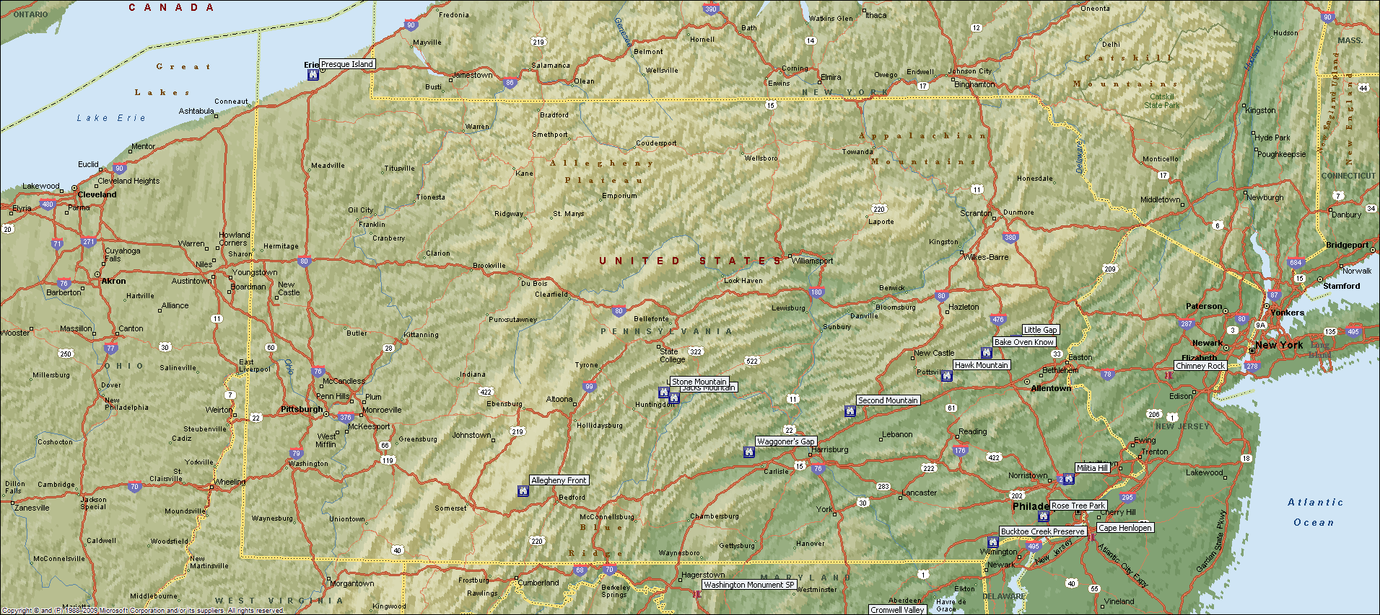
Allegheny Front Hawk Watch is the hawksite furthest to the West!
- Since the Allegheny Front Hawk Watch is on the western most ridge, and all of the migrating raptors follow this superhighway, what direction wind will push raptors towards the Allegheny Front Hawk Watch?

- Using the same logic, which winds would be the least beneficial for pushing the raptors to the Allegheny Front Hawk Watch?

- Can you guess which wind hawkwatchers prefer at the Allegheny Front Hawk Watch?

- Ask one of the hawkwatchers at the Allegheny Front Hawk Watch which wind they prefer. What was there response?
16
Activity 5 – Word Search

EAGLE FALCON
HAWKWATCHING MERLIN
OSPREY RAPTOR
SHARP-SHINNED RED-TAILED
VULTURE LIFT
WING BUTEO

Z R G F B T X Z N E H X D T W M D Z Q M
Z C W N B T C D O Q Q G E I J O K G R E
S X A S I U P S Q G Q K L N Y N C P L R
D E N N I H S P R A H S I I B L W J R L
E U E S E P C I H K V Y A S Q W Y E L I
G R X A Q L T T J V U L T U R E I S N N
Y E R P S O G I A C I M D K R R M W G E
A Q Q X M L R A H W U T E L R A R O Y K
L G H T I A B G E U K X R A T K P Q S W
T M F R G L Q O O M Q W H K Q W A T Z A
B I O M M F E O M P D T A Z I U O R O H
L B Y Y Y C T F K M P R D H X L D H F R
I F D I Z U V J A U T W T A F L Q A W O
E I B A S D V Q H H A L E B Q W L H U R
O C A C E V I B U R Z N D Q E C X M I D
E M C W D K L Z U O W I N G O P S I D O
F A X B F K S D W Y R Q T N U A B E S C
W W I J V S T D O Y J Z L G Q W X P O J
R X F Z J E H A P W K J W K C V D Y O M
K Q F M P U Y Y Q O C E Z S H B F R Y X

9
Activity 6 – Broad-Winged Hawk
Below is a picture of a Broad-winged Hawk in flight. Answer the following descriptive questions.
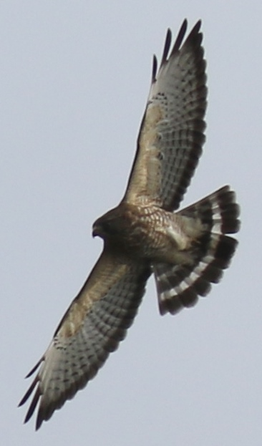
- What do you notice about the tail shape?

- Is there a large band in the tail?

- What color is the outline of the wing?

- What do you notice about the shape of the wing?

- Is the trailing edge of the wing curved or straight?

10
Activity 11 – Counting Raptors
Count the number of Raptors that migrate past the site.

- How many birds total did you count for your stay?

- How many of the birds were raptors?

- How many other birds did you count?

- What was your favorite bird of the day?

- Did you see an eagle?

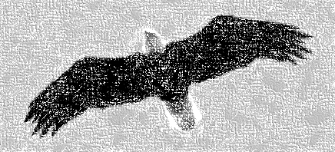
- What is the easiest bird to identify?

15
Activity 10 – Connect the Raptors to the Name
Draw a line from the Raptor to their description. You may use the resources located on the picnic table to help answer these questions.

Turkey Vulture -Has a big white head

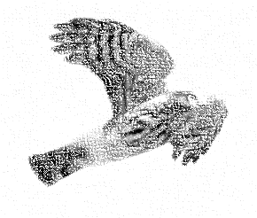
Bald Eagle -Adults have red tails

Osprey -Large black raptor that rocks in the air

Sharp-shinned Hawk -Has a golden nape on back of head

Red-Tailed Hawk -Large black raptor with a very short tail

Golden Eagle -Looks like a large Sharp-shinned Hawk

Broad-winged Hawk -Fastest of all raptors

Cooper’s Hawk -In flight, it looks like a giant M

Black Vulture -A small-headed, snappy, spastic raptor

Peregrine Falcon -Large black and white tail bands

14
Activity 7 – Merlin
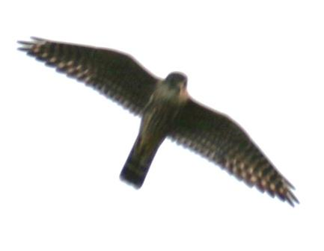
- What do you notice about the tail shape?

- Are the wings dark or light colored?

- Do the wings look triangular?

- Are the wings slim or fat?

- Is the trailing edge of the wing curved or straight?

11
Activity 8 – Sketch a Migrating Raptor
Use the space below to sketch a migrating raptor. Some ideas to consider when drawing are:
- Where are the areas of dark on the bird?
- How long are the wings compared to the overall length of the bird?
- Is the tail long or short, fat or slender, banded or not?

12
Activity 9 – Taking the Weather
At the beginning of the hour, take the environmental data using your senses. A few helpful hints are given below:
- Counters mark the direction that this wind is coming from.
- The picnic table is east of the Porto-John.
- Wind that pushes you towards the edge is from the west.
Circle the Wind Direction:
N NE E SE S SW W NW
N
S
W
E

Wind Speed:
None Slight Medium Fast Very Fast

Precipitation:
None Mist Rain Snow

Sunlight:
Hazy Overcast Partial Sun Full Sun

Temperature:
Very Cold Cold Comfortable Warm Hot

Visibility:
Can’t See the Valley Can See the Far Ridges Clear

13

